Conversational AI on Google Cloud
Gemini-Powered Policy & Knowledge Assistant
Customer & Employee Facing — Implementation Document

Author
Harikrishnan Rajaram
Version | Status | Date | Classification
1.0 | Draft for Review | June 20, 2026 | Internal

Document Control
Version | Date | Author | Summary of change
0.1 | — | Harikrishnan Rajaram | Initial draft of architecture and approach
1.0 | — | Harikrishnan Rajaram | Completed implementation plan, security, and rollout

Table of Contents
1. Executive Summary 3
2. Solution Overview 3
2.1 Objectives 3
2.2 Scope 3
3. Architecture 3
3.1 Layer responsibilities 4
3.2 Two-channel design 5
4. Technology Stack 5
5. Request Lifecycle 6
6. Security, Privacy & Compliance 6
7. Performance & Latency 7
8. Implementation Plan 7
8.1 – 8.6 Phases 0 to 5 7
8.7 Phase 6 — Hardening and pilot 8
9. Hosting & Deployment 8
10. Evaluation & Model Risk 8
11. Operations & Monitoring 8
12. Rollout Timeline 9
13. Appendix — Deliverables 9

1. Executive Summary
This document describes the architecture, design, hosting approach, and step-by-step implementation plan for a conversational AI assistant built on Google Cloud. The assistant answers policy and knowledge questions for two audiences from a single shared engine: a customer-facing channel embedded in web and mobile apps, and an internal channel that assists employees and contact-centre agents.
The solution uses a retrieval-augmented generation (RAG) pattern. Approved documents are ingested once into a managed index. At query time the user's question is screened and de-identified, the most relevant passages are retrieved, and a Gemini model produces a grounded, cited answer drawn only from those passages. When the answer is not in the corpus, the assistant abstains rather than speculating. The design deliberately favours Google Cloud managed services so the team can reach production quickly while meeting the security, privacy, and auditability expectations of a regulated environment.

2. Solution Overview
At its core the system is a question-answering service grounded in a trusted document corpus. The same engine is exposed through two front doors that differ only in identity, data scope, persona, and guardrail strictness.

2.1 Objectives
- Provide fast, accurate, citation-backed answers to policy and knowledge questions.
- Serve customers and employees from one maintainable codebase.
- Eliminate hallucination by grounding every answer in retrieved source documents.
- Protect sensitive data through automated PII detection and redaction.
- Produce a complete, immutable audit trail for governance and model-risk review.

2.2 Scope
In scope: grounded Q&A over approved policy and procedure documents, two delivery channels, guardrails, audit logging, and evaluation. Out of scope for the initial release: money movement and other transactions, real-time account-specific data, and open-ended general chat. These require secured API tooling and can be added on the same foundation later.

3. Architecture
The reference architecture is organised into seven layers, from user channels at the top down to the batch ingestion pipeline. Each layer is colour-coded in the diagram below by responsibility.
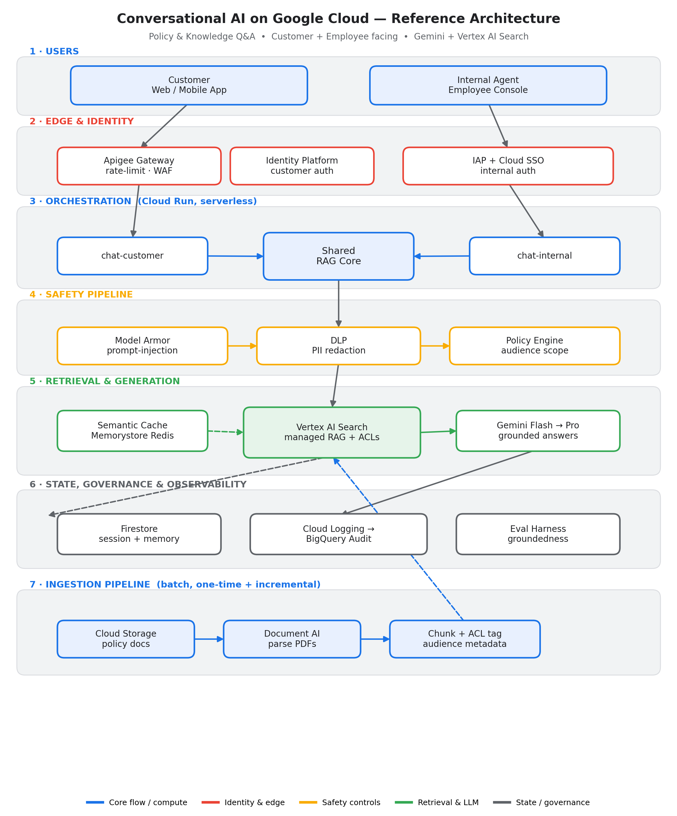
Figure 1. Reference architecture — layered view

3.1 Layer responsibilities
Layer | Responsibility | Key services
Users | Customer and employee entry points | Web / mobile app, agent console
Edge & Identity | Authentication, rate limiting, WAF | Apigee, Identity Platform, IAP + SSO
Orchestration | Request handling, channel logic | Cloud Run (serverless)
Safety pipeline | Attack screening, PII redaction, scope | Model Armor, Sensitive Data Protection
Retrieval & Generation | Grounded answers with citations | Vertex AI Search, Gemini, Memorystore
State & Governance | Memory, audit, evaluation | Firestore, BigQuery, eval harness
Ingestion | Parse, chunk, index documents | Cloud Storage, Document AI

3.2 Two-channel design
Both channels call the same RAG core. A single audience flag drives three things: the system prompt and persona, the document access-control filter applied at retrieval, and the strictness of the guardrail profile. This keeps one codebase while enforcing that customers never see internal procedures.
Aspect | Customer channel | Internal channel
Authentication | Identity Platform | IAP + corporate SSO
Document scope | Public-safe policy only | Public + internal procedures
Persona | Plain, friendly, with disclaimer | Concise, procedural, citation-heavy
Guardrails | Strict; no advice; hard PII redaction | Strict PII redaction; broader scope
Extras | Escalate to human | Summarise, suggest next step

4. Technology Stack
All components are Google Cloud managed services, chosen to minimise build effort and operational burden while satisfying enterprise controls.
Capability | Service | Why this choice
Managed RAG | Vertex AI Search | Parsing, chunking, embedding, retrieval, and document ACLs out of the box
Generation | Gemini (Flash / Pro) | Low-latency default with escalation for complex reasoning
Orchestration | Cloud Run | Serverless, scales to zero, deploys from source
PII protection | Sensitive Data Protection | Detect and redact sensitive identifiers before LLM and logs
Attack defence | Model Armor | Screens for prompt injection, jailbreak, unsafe content
Memory | Firestore | Low-latency session and conversation state
Cache | Memorystore (Redis) | Semantic cache for repeated questions
Audit & analytics | BigQuery | Immutable, queryable interaction log
API management | Apigee | Rate limiting, keys, WAF at the edge

5. Request Lifecycle
A single customer or agent turn flows through the system as follows:
- The request arrives through Apigee (customer) or IAP (internal) after authentication.
- Model Armor screens the input for prompt-injection and unsafe content.
- Sensitive Data Protection redacts any PII from the message before further processing.
- The semantic cache is checked; a hit returns immediately.
- On a miss, Vertex AI Search retrieves the top passages, filtered by the channel's access-control scope.
- Gemini generates a grounded answer with citations, abstaining if the corpus lacks the answer.
- The output passes a final safety screen; low-confidence customer answers trigger human escalation.
- Session memory is updated and an immutable audit record is written to BigQuery.

6. Security, Privacy & Compliance
Security and compliance are designed in, not added later. Each obligation maps to a concrete control.
Obligation | Control in this design
Data privacy | PII redaction before the LLM and before any log; CMEK encryption; VPC Service Controls perimeter
Model risk | Evaluation harness scores groundedness and accuracy on a golden set before every release
Auditability | Every turn logged immutably to BigQuery: question, sources, answer, model, latency
No unauthorised advice | System prompt forbids personalised advice and appends disclaimers
Hallucination control | Grounded generation only, with citations and an explicit abstention path
Human oversight | Low-confidence or out-of-scope answers escalate to a human agent
Data residency | All services pinned to an approved region

7. Performance & Latency
Responsiveness is treated as a first-class requirement. The following techniques keep perceived latency low:
- Token streaming so the first words appear in roughly half a second.
- A semantic cache that returns repeated policy questions in tens of milliseconds.
- Gemini Flash as the default model, escalating to Pro only when complexity warrants.
- A minimum of one warm Cloud Run instance to avoid cold starts on the hot path.
- Co-location of all services in a single region to remove network round-trips.
- Parallel execution of input guardrails and cache lookup where safe.

8. Implementation Plan
The build proceeds in clearly bounded phases. Each phase produces a verifiable outcome.

8.1 Phase 0 — Project setup
Create the Google Cloud project, set the region, and enable the required APIs (Cloud Run, Vertex AI, Discovery Engine, DLP, Firestore, Document AI, Redis, Apigee, Logging, BigQuery, KMS).

8.2 Phase 1 — Provision infrastructure
Apply the Terraform configuration to create the document bucket, the Vertex AI Search data store and app, Firestore, Memorystore, the BigQuery audit dataset, and least-privilege service accounts.

8.3 Phase 2 — Ingest documents
Upload policy documents to Cloud Storage tagged with an audience label, then run the ingestion job. Vertex AI Search parses, chunks, embeds, and indexes automatically; the audience label becomes the per-channel access-control filter.

8.4 Phase 3 — Deploy the orchestration service
Deploy the orchestration container to Cloud Run with a minimum instance count, exposing the customer and internal front doors.

8.5 Phase 4 — Identity and gateway
Wire Apigee and Identity Platform in front of the customer channel, and IAP with corporate SSO in front of the internal channel. Configure rate limits and WAF policy.

8.6 Phase 5 — Observability and evaluation
Confirm audit records land in BigQuery and run the evaluation harness against the golden question set, blocking release if quality thresholds are not met.

8.7 Phase 6 — Hardening and pilot
Enable VPC Service Controls and CMEK, complete prompt-injection red-teaming, verify disclaimer and escalation behaviour, load-test to the latency target, then open a limited pilot.

9. Hosting & Deployment
The service is hosted entirely on Google Cloud. Cloud Run runs the stateless orchestration container and scales automatically with demand; the retrieval index, models, cache, memory, and audit store are all managed services. Infrastructure is defined as code in Terraform so environments are reproducible, and deployments are promoted from development to staging to production with the evaluation gate enforced between stages.
Environment | Purpose | Promotion gate
Development | Build and integrate features | Unit tests pass
Staging | Pre-production validation | Evaluation thresholds met; security review
Production | Live customer and agent traffic | Change approval; rollback plan ready

10. Evaluation & Model Risk
The assistant is governed like a model, not merely a feature. A golden set of representative questions with verified answers and sources is maintained and replayed before every release. Releases are blocked if groundedness, accuracy, citation correctness, refusal behaviour, or injection resistance fall below their thresholds, and results are retained for model-risk review.
Metric | What it protects against | Target
Groundedness | Hallucination | High
Answer accuracy | Incorrect responses | High
Citation correctness | Misattributed sources | High
Refusal correctness | Answering beyond the corpus | High
PII leakage | Privacy breach | Zero incidents
Injection resistance | Manipulation of the assistant | Very high

11. Operations & Monitoring
Operational health is observed through Cloud Logging and BigQuery dashboards covering latency, cache hit rate, abstention and escalation rates, and error rates. Alerts fire on latency-SLO breaches and on any detected PII leakage. Document changes trigger a re-evaluation because new content can shift retrieval behaviour.

12. Rollout Timeline
A pragmatic four-week path to a hardened pilot, starting with a single high-value policy domain and expanding the corpus once quality and audit are proven.
Week | Focus | Outcome
1 | Project setup, infrastructure, initial ingestion | Indexed corpus, infra in place
2 | Both channels and baseline guardrails | End-to-end answers on both channels
3 | Evaluation, audit, cache, load testing | Quality gate and performance verified
4 | Security hardening and red-teaming | Limited pilot launched

13. Appendix — Deliverables
This document is accompanied by an implementation repository containing the infrastructure code, the orchestration service, the ingestion job, and the evaluation guide:
- Infrastructure as code (Terraform) for all Google Cloud resources.
- Orchestration service (FastAPI on Cloud Run) with retrieval, guardrails, and audit.
- Ingestion job that indexes documents into Vertex AI Search with access-control tags.
- Evaluation guide describing the golden set and the model-risk gate.
Prepared by Harikrishnan Rajaram.

